Word2Vec is a technique used in Natural Language Processing (NLP) to convert words into numerical vectors (embeddings) so that machines can understand their meanings.

Why do we need Word2Vec?
Computers don’t understand text directly.
They only understand numbers.
Old methods like:
- Bag of Words
- TF-IDF
Represent words as sparse vectors (mostly zeros)
Do NOT capture meaning or relationships between words
Word2Vec solves this by:
- Learning dense vector representations
- Capturing semantic relationships

What does Word2Vec do?
It converts each word into a fixed-length vector (e.g., 100 or 300 dimensions).
Example:
King → [0.21, -0.45, 0.78, ...]
Queen → [0.19, -0.40, 0.75, ...]
Man → [0.30, -0.20, 0.60, ...]
Woman → [0.28, -0.18, 0.59, ...]
These vectors capture meaning.
It can perform word analogies using vector math:
King - Man + Woman ≈ Queen
This works because similar words have similar vector representations.

How Word2Vec Works
It uses a shallow neural network and learns word embeddings using context.
There are two main models:

CBOW (Continuous Bag of Words)
- Predicts a word from surrounding context words.
- Example:
- "I love ____ very much"
- Predicts machine learning

Skip-Gram
- Predicts surrounding words from a given word.
- Example:
Input: "learning"
Output: "machine", "deep", "AI"
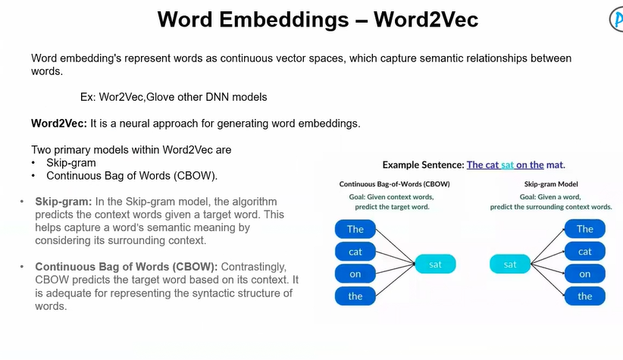
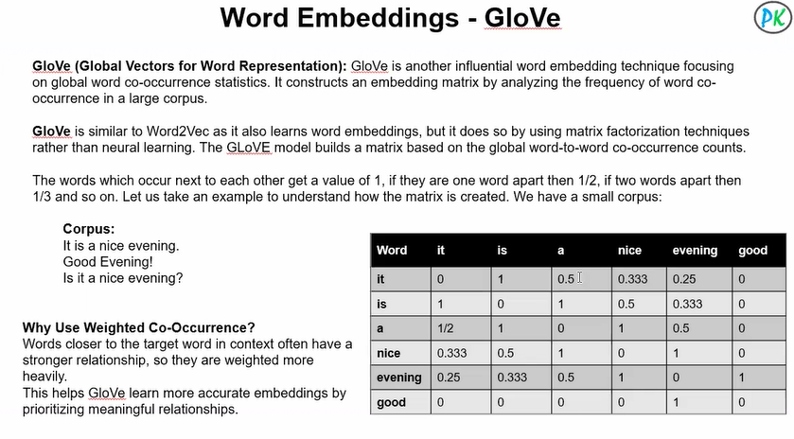
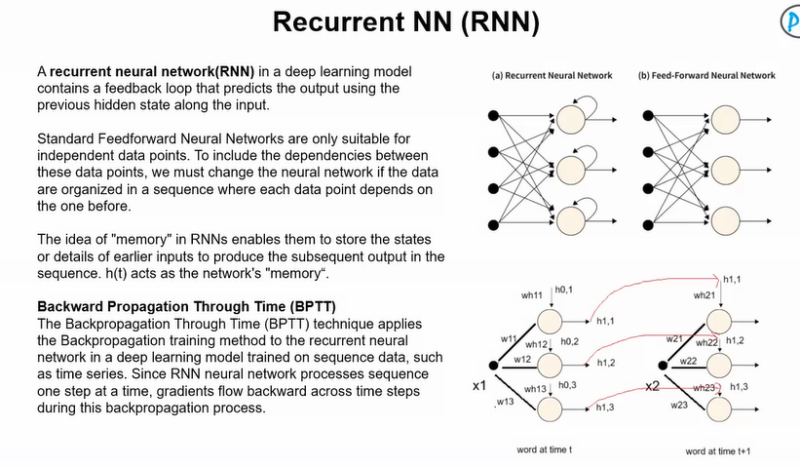
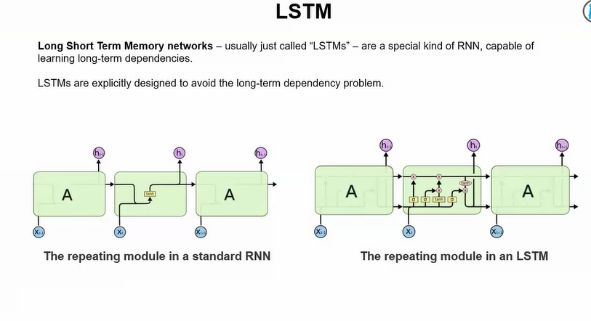
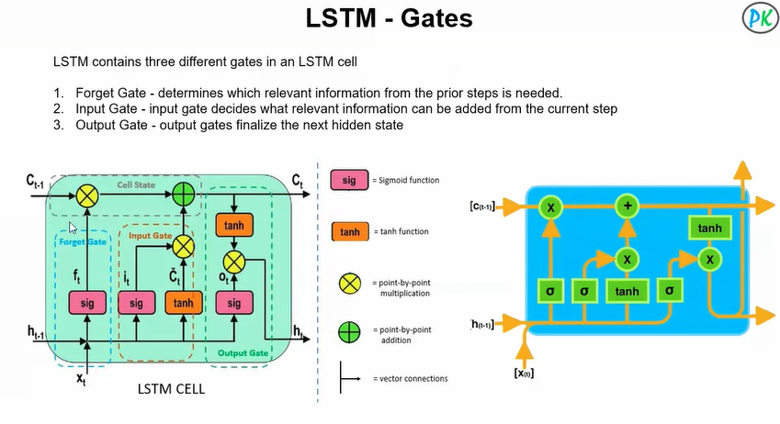

What is Prompt Engineering?
Prompt Engineering is the skill of designing effective inputs (prompts) to guide a GenAI model to produce better outputs.
A prompt = the instruction you give to the AI.
Since GenAI models respond based on patterns learned from data, the quality of output heavily depends on how you ask the question.

